Project Design Phase-II
Data Flow Diagram & User Stories

Date | 31 January 2025
Team ID
Project Name
Maximum Marks | 4 Marks

Data Flow Diagram
The Data Flow Diagram (DFD) shows how data moves through the Library Book Request System. It illustrates how students submit book requests, how the system validates and stores the information, and how the librarian receives notifications and manages the requests.

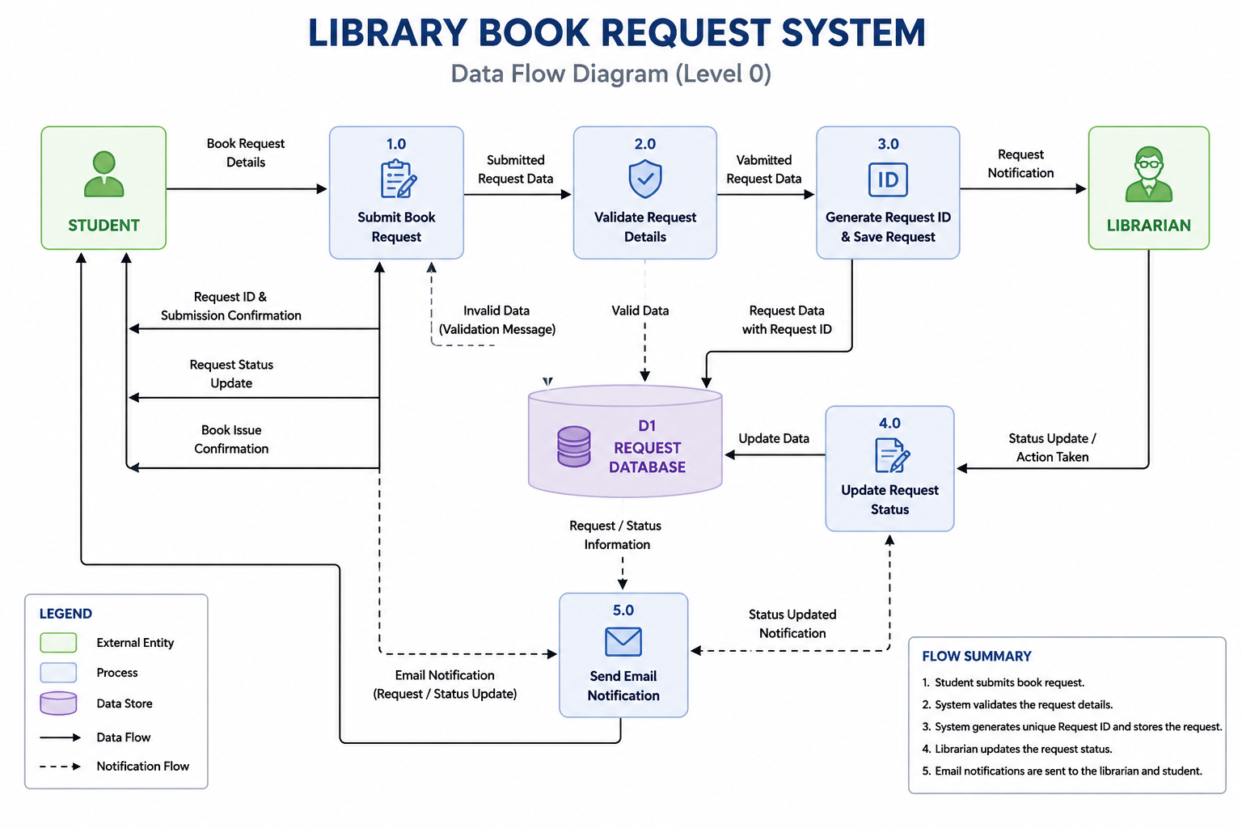

User Stories

User Type | Functional  Requirement  (Epic) | User Story  Number | User Story / Task | Acceptance criteria | Priority | Release
Student | Book Request | USN-1 | As a student, I can submit a library book request by entering book and personal details. | Book request is submitted successfully. | High | Sprint-1
Student | Issue Date Validation | USN-2 | As a student, I can select only the current or future issue date. | Past dates are not accepted. | High | Sprint-1
Student | Request  Tracking | USN-3 | As a student, I can view my submitted request details. | Submitted request is displayed correctly. | Medium | Sprint-1
System | Request ID Generation | USN-4 | As a system, I automatically generate a unique Request ID for every request. | Unique Request ID is created automatically. | High | Sprint-1
Librarian | Email Notification | USN-5 | As a librarian, I receive an email when a new request is submitted. | Email notification is received successfully. | High | Sprint-2
Librarian | Review Request | USN-6 | As a librarian, I can review student book requests. | Request details are displayed correctly. | Medium | Sprint-2
Librarian | Comments | USN-7 | As a librarian, I can add comments for the student's request. | Comments are saved successfully. | Low | Sprint-2
Librarian | Request Management | USN-8 | As a librarian, I can manage all submitted book requests. | All requests can be viewed and managed. | Medium | Sprint-2

